CIRCULAM VITAE(SALES/MARKETING)

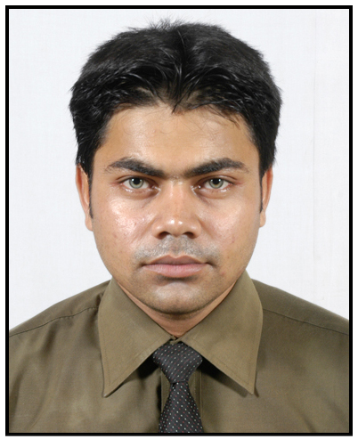

NAME: PRASANTA BHATTACHARJEE  MBA (MARKETING ) | Permanent Address: 12/6 KALIPUR KANCHA ROAD,HARIDEVPUR,  KOLKATA  PIN CODE : 700082  Email: pbhattacharya832@gmail.com  Phone: 9038007309
OBJECTIVE:
SEEKING A CHALLENGING CARRER IN AN ORGANIZATION WHICH PROVIDES ME THE LEARNING OPPORTUNITIES TO MAKE POSITIVE CONTRIBUTION TO THE MANAGEMENT OF BUSINESS ACTIVITIES AND PERSONAL GROTH THROUGH TEAM EFFORTS.
ACADEMIC QUALIFICATION:

Qualification | Percentage | Institute/Board/University
MADHAYAMIK  2003 | 58.5% | W.B.B.S.E,WEST EBNGAL
HIGHER SECONDARY  2005 | 56.5% | W.B.C.H.S.E,WEST BENGAL
B.COM(HONS)  2008 | 50% | CALCUTTA UNIVERSITY, WEST BENGAL
M.B.A  2011 | 61% | M.M.I, GHAZIABAD

PROFESSIONAL STRENGHTS / SKILLS :
- ABILITY TO WORK NEW AND CHALLENGING ENVIRONMENT.
- WILLINGNESS TO WORK IN GROUPS.
- WIILLINGNESS TO LEARN NEW CONCEPT, IDEAS & USE NEW TECHNOLOGIES.
- ATTITUDE TO SHARE INFORMATION & NEW KNOWLEDGE.
- CONVINCING POWER.
- TEAM WORK.
- SOFT SKILL.

ADDITIONAL QUALIFICATION:

M.S.DOS, M.S.OFFICE, ACCOUNTING PACKAGE.

WORKING EXPERIENCE:
1) Worked Coral Laboratories Ltd (Division of DWD), join as a medical representative (11 October 2010 – 30 April 2011) 7 months
  - Visited Doctor and promote existing and new medical product.

Visited chemist and medical shop for updating sales.

2) Worked Infocom Network Ltd (Trade India), as a business development executive from ( 2nd May`2011 to 6th May 2013) 2 years
  - Responsible for Customer creation and customer maintenance.
  - Handling marketing of Online and Offline Catalog,
  - Handling the profile of Company Hosting (e.g. Yahoo, Google etc.)
  - Provide the facility of Website Creation to the customer.
  - Promote company profile through media,advertishment(online,offline,print)

Current working:

Working, Just Dial Limited as a senior marketing executive. (Oct 2013 to continue….

- Visited appoinment call and promote the company services to the target customer.

- Monthly target meet and genarating company revinue.

PERSONAL PROFILE:

FATHER’S NAME |  | SHRI ALOKE BHATTACHARJEE
DATE OF BIRTH | : | 4TH OCT 1986
GENDER | : | MALE
NATIONALITY | : | INDIAN
LANGUAGE :  READ/WRITE/ SPEAK | : | BENGALI : READ WRITE & SPEAK ENGLISH : READ WRITE & SPEAK  HINDI :READ & SPEAK
INTEREST | : | SPORTS & TRAVELLING

Signature

